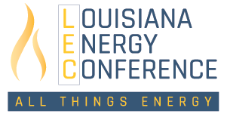
Instructions for Registration & Finalizing Personal Conference Details
Thank you for your interest in registering for the 2024 Louisiana Energy Conference in New Orleans. This document includes important information on registering and finalizing your personal conference details.
Please Complete These Three Steps to Secure Your Registration:
1. Access the Louisiana Energy Conference registration platform through the Issuer Direct portal;
2. Login to the Issuer Direct portal;
3. Follow the registration steps.
You Must also Complete These Four Steps to Finalize Your Personal Agenda:
1. Select your attendance options for events and meals you plan to attend;
2. Select your availability and/or preferences for one-on-one meetings;
3. Upload your picture to your profile for networking;
4. Download the conference app, ID Conference, from the App Store or Google.
REGISTRATION
- Click the registration link here or on the LEC website,
- Login to the Issuer Direct portal,
  - If you have used Issuer Direct previously for conference registration, input your email address used previously and corresponding password,
    - Click “Forgot your password?” if you need to reset,
  - If you are new to Issuer Direct, input your email address you would like to use for conference registration and create a password,
  - Please note: you have the option for someone from your company to act in the role of representative and register all of your attendees,
- Select your PARTICIPANT TYPE and click continue,
  - Sponsor Firms will need company specific promotion code to complete registration,
  - Panelist Firms will need specific promotion code to complete registration,
  - General Attendees will need to make an additional PARTICIPANT TYPE selection before moving forward,
- Select your TICKET TYPE and click continue,
- Complete/review your PROFILE using the populated data fields and click continue,
- Within the PAYMENT section, review billing details for accuracy, input promotion code if applicable and click finish payment,
- Once your registration is complete, the portal will take you to your conference profile. Be sure to complete your agenda for the week to help us best serve you during all events.
PERSONAL AGENDA
- Select Attendance Options to Generate your Personal Agenda
Once you are fully registered, the portal will take you to your profile. At this time, you can select your agenda items to indicate events and meals you plan to attend. Please note, multiple events this year have space limits set by the venue, we suggest planning your agenda early.
If you registered previously and you have not already done so, please click the login link below to enter your profile. Within your agenda section, you can select your event and meal attendance for the Conference.
UPDATE YOUR “AGENDA” HERE
You can mark your preferred events by selecting the specific times you will be available in the AGENDA section on the top right menu of the profile page. Once you are in the AGENDA section, scroll through the list of meals/events and click ADD for the events offered that you would like to attend.
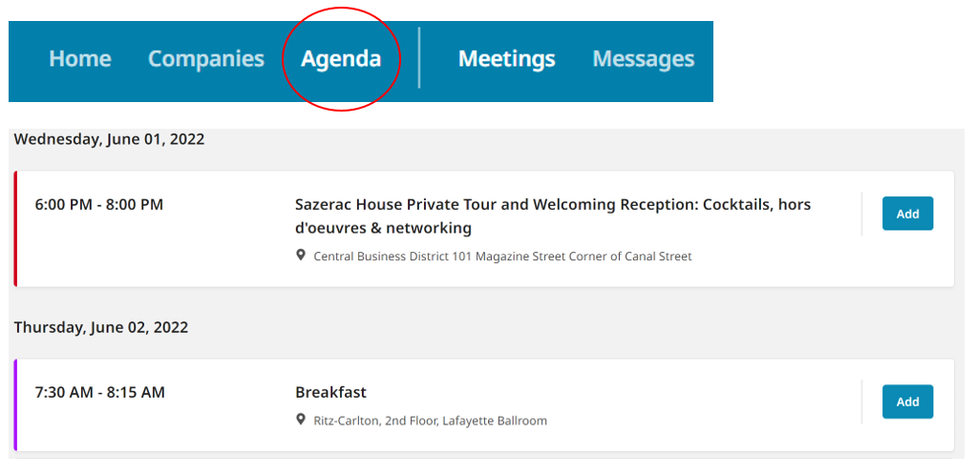

Conference Receptions
Tuesday, May 38th
Opening Reception, 5:30-7:30pm, Vue Orleans, 2 Canal Street, 34th Floor, New Orleans

Wednesday, May 29th
Networking Reception, 6:00-8:00pm, Sazerac House, 101 Magazine Street, New Orleans
Note: Mini-bus transportation will leave the Four Seasons traveling to the reception beginning at 5:45 pm and continuing until 7:45 pm.

2. One-on-One Availability, for Investment Professionals
Once you are fully registered, the portal will take you to your profile. You can indicate you want to be available for one-on-one meetings with attendees.
If you registered previously and you have not already done so, please click the login link below to enter your profile.
UPDATE YOUR “AVAILABILITY” HERE
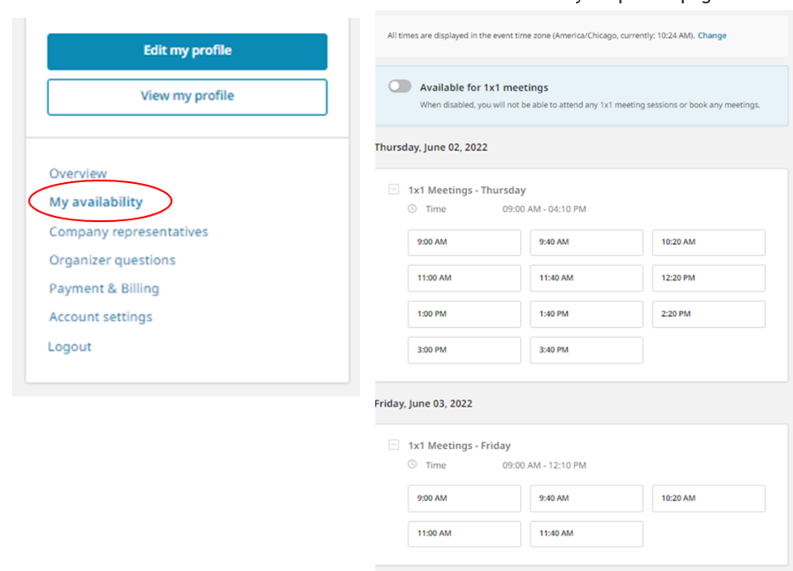
You can mark your preferred one-on-one meeting slots by selecting the specific times you will be available in the MY AVAILABILITY section on the left side menu of your profile page.

Next you will want to go into the MEETINGS section (upper right side) to make or view request for meetings.
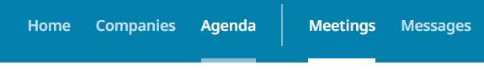

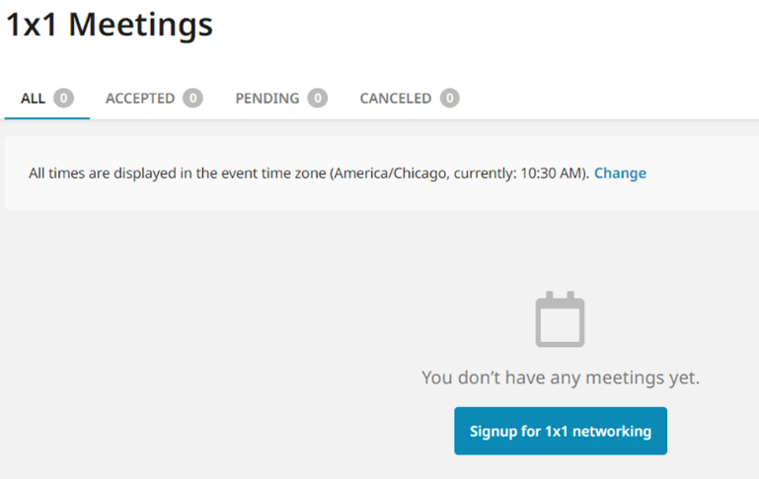
Please keep in mind that many of our guests prefer to attend our panels which may limit the number of one-on-one requests you will receive compared with requests you may receive for other conferences. If you plan to host one-on-one meetings, we will provide you with a list of requests shortly before the Conference and you will be asked to confirm or decline your meeting requests.

3. Upload a Profile Picture
Uploading a profile picture to your profile is great for networking and preparing for one-on-one meetings.
UPDATE YOUR “PICTURE” HERE
While logged in, on the left side of your profile OVERVIEW page, there will be a circle with your initials and a plus sign.
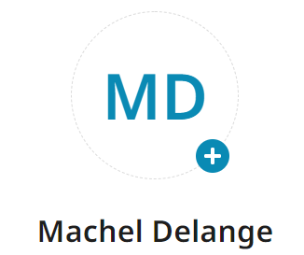
Click the plus sign and follow the prompts to upload your picture.

4. Download the Conference App
Our conference software developer, Issuer Direct, has an app that supports their conferences, ID CONFERENCE. Access to your agenda, one-on-one details, and attendees is available through the app.
You can download this app from any of the App Stores by searching for Issuer Direct or ID CONFERENCE.
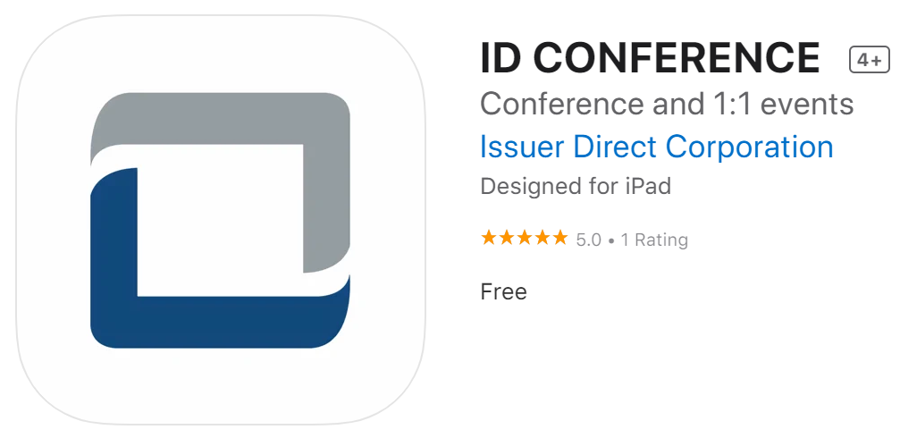
We look forward to welcoming you at this year’s event. Please email or call Machel Delange or Al Petrie with any questions.
_{Machel Delange}
_{machel@alpetrie.com}
_{Cell: 512-563-3745}

_{Al Petrie}
_{al@alpetrie.com}
Office: 504-799-1953, Cell: 504-258-9548

