Instructions for Conference 1x1 Registration
Thank you for registering for the 2024 Louisiana Energy Conference in New Orleans. Please note, if you have not already registered, do so by clicking here. This document includes important information on registering for 1x1 sessions at the conference.
If you have already completed your registration, please complete these one-on-one meetings steps to indicate your availability:
One-on-One Availability
Once you have logged in to the Issuer Direct portal, you can indicate you want to be available for 1x1 meetings with attendees by going to the MY AVAILABILITY section on the left side menu of your profile page.
UPDATE YOUR “AVAILABILITY” HERE
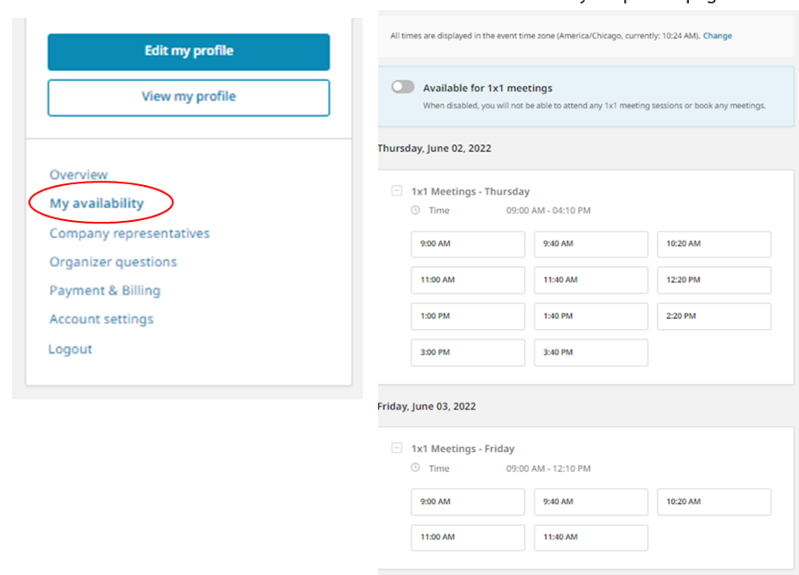
First, make sure your profile is set for 1x1s by moving the toggle button next to AVAILABLE FOR 1X1 MEETINGS, it should turn BLUE. At this point, all days of the conference will be selected with a check mark and all time slots will turn GREEN. You can adjust your preferred 1x1 meeting slots by deselecting the specific times you will not be available, either the whole day or specific times within the day.

Next you will want to go into the MEETINGS section (upper right side) to make or view request(s) for meetings. You will want to check this area frequently after you register to ACCEPT or DECLINE meetings that have been requested of you.

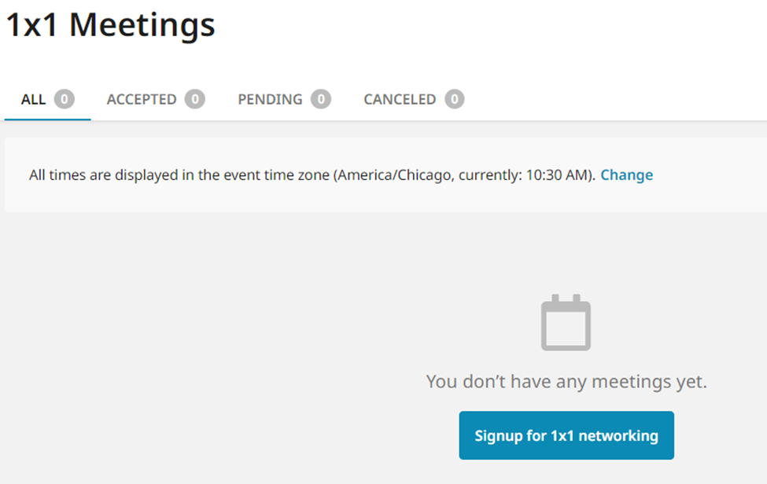

Please keep in mind that many of our guests prefer to attend our panels which may limit the number of one-on-one requests you will receive compared with requests you may receive for other conferences. If you plan to host one-on-one meetings, we will provide you with a list of requests shortly before the Conference and you will be asked to confirm or decline your meeting requests.
Three weeks before the conference, our team will work the 1x1 schedule to arrange meetings that have been REQUESTED and ACCEPTED. You will receive a meeting schedule around May 27.
We look forward to welcoming you at this year’s event. Please email or call Machel Delange or Al Petrie with any questions.
_{Machel Delange}
_{machel@alpetrie.com}
_{Cell: 512-563-3745}

_{Al Petrie}
_{al@alpetrie.com}
Office: 504-799-1953, Cell: 504-258-9548

